Lab 5. Update, Delete

- Update Endpoint (PUT)

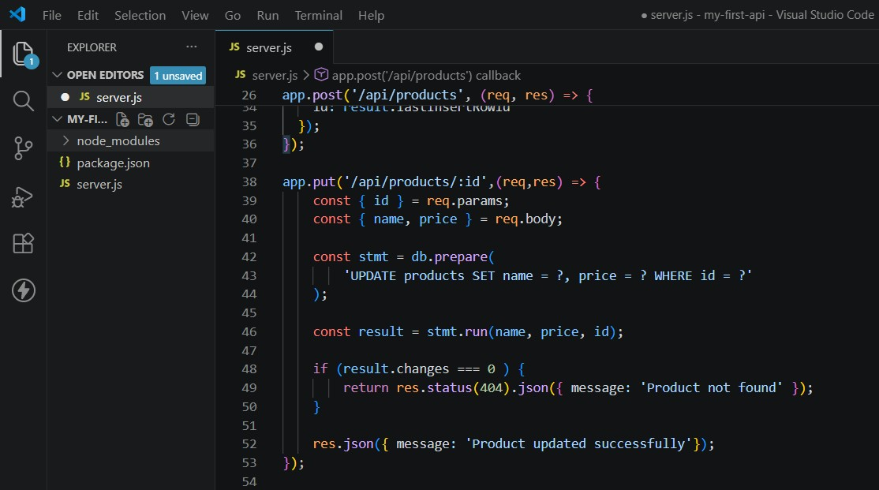

- Delete Endpoint

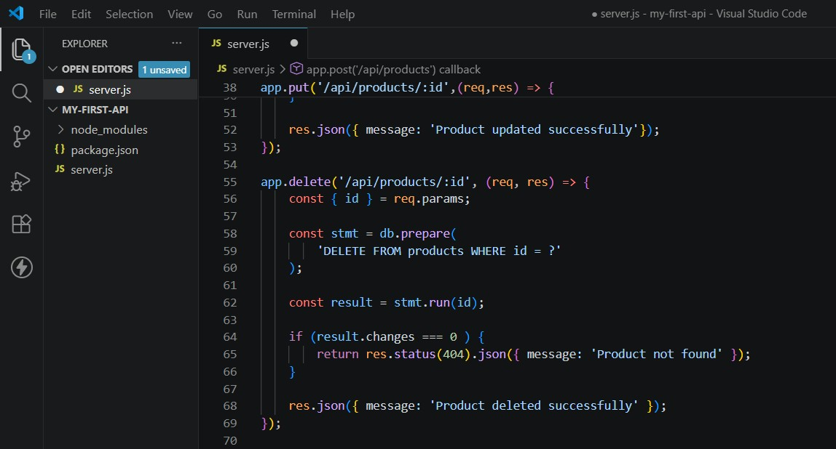

GET
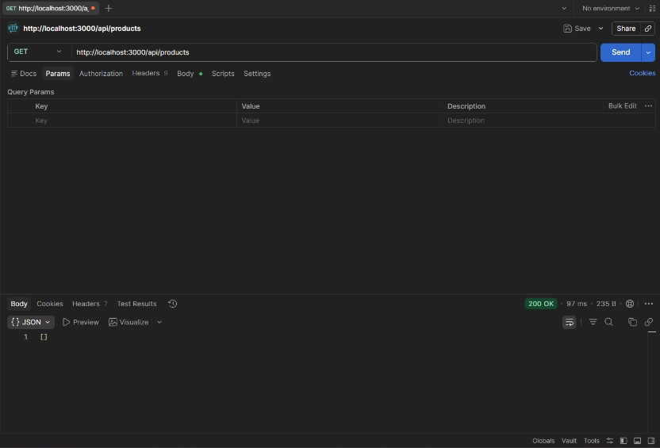

POST
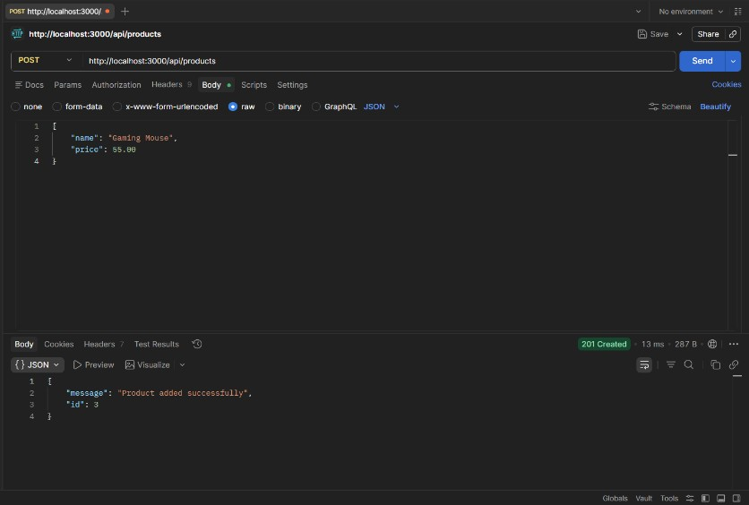
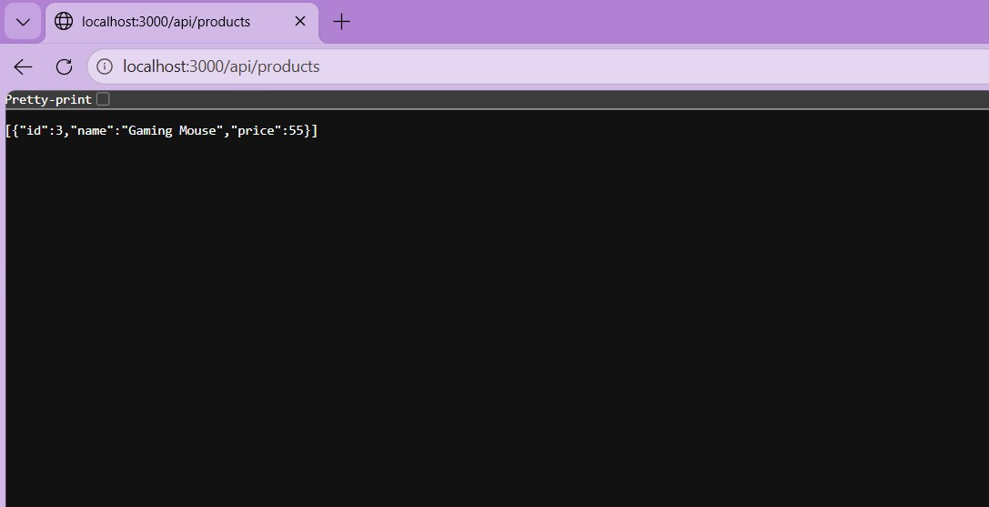
DELETE
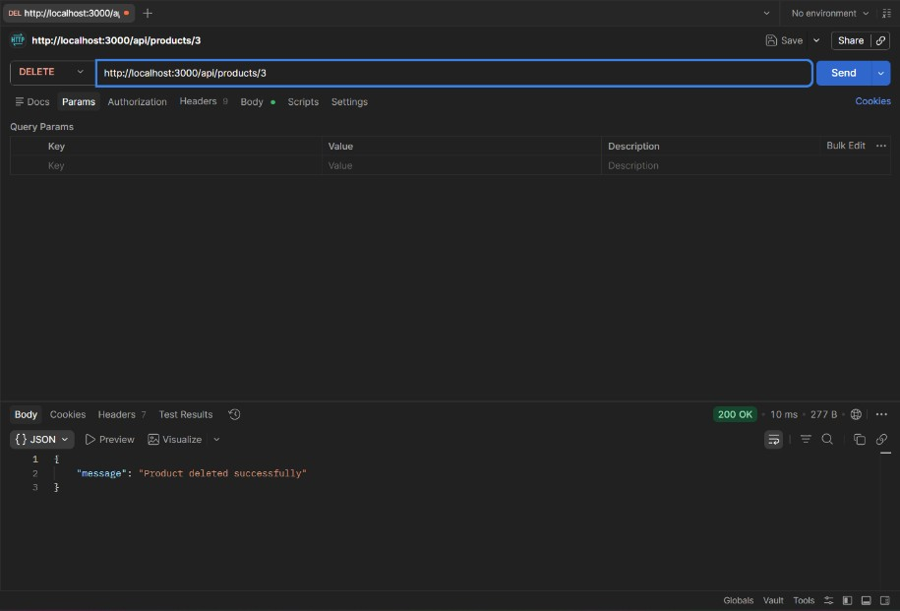

Questions:

- Why is PUT used for updating data instead of POST? Think about the “Strict Synchronous Contract”
  - PUT is idempotent, meaning sending the same request multiple times produces the same result. While POST is mainly used for creating new resources; it is non-idempotent, meaning that sending multiple requests can create duplicates.
- In your DELETE logic, why is it better to return a 404 error if the ID doesn’t exist, rather than just sending a “Success” message anyway?
  - Returning a 404 error when the ID does not exist is better because it clearly indicates that the resource is not found, instead of misleading the client with a success message. This improves API reliability and makes debugging easier.
- You’ve now built a full CRUD API. If you were to connect a React or Mobile app to this, which part of the “Modern API Architecture” would this Node.js server represent?
  - The backend API layer (application server) in a modern API architecture, handling requests from the React or mobile app and processes business logic and communication with the database.

